MEVA

Metabolite Enrichment Visualization Analysis

MEVA is a metabolite profiling tool built into the Cytoscape network visualization software. MEVA takes fold change, p-value, and z-score data and determines which metabolic pathways are differentially varied. It then returns a list of pathways with pertinent information. Each of these pathways can be loaded into a dynamic network that allows for visual mappings of the nodes and edges based on the loaded data. These mappings include adjusting the color, shape, size, etc. of the nodes and edges. Users may then export the data analysis results as a tab delimited text file and the networks as several image file types such as jpeg and svg.

Step by step instructions for running the MEVA application

* Install app from the app manager in the app menu by selecting “install from file” and locating the jar file.
* To run an analysis, simply import your data, add any custom pathways you’d like, and tell it to run.

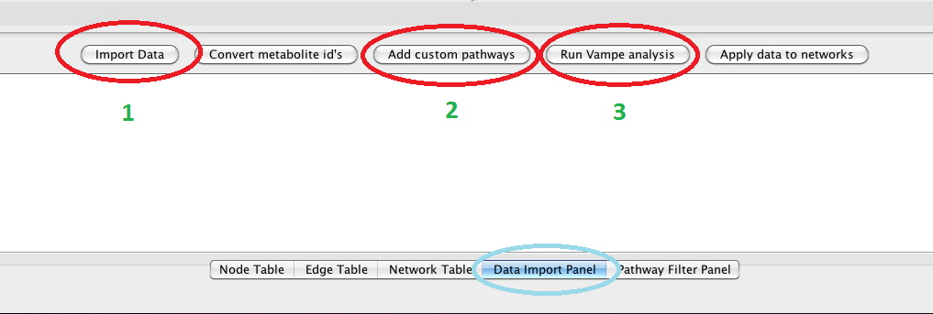

* In the **Data Import Panel**, select “import data” and locate a tab-delimited (.txt) or comma separated values (.csv) file with the data you would like to analyze.
* Making sure the HMDB or KEGG id’s are to the left of your data, select two columns of data by highlighting at least one element of data in each column. This can be done by clicking and dragging, control + click on a pc, or command + click on a mac. HMDB identifiers are preferred, as many KEGG identifiers map to the same HMDB metabolite.
* With the two columns of data highlighted, pressing the “run MEVA analysis” button will produce your analysis, which will be shown in the **Pathway Filter Panel**.
* By selecting the “add custom pathways” button, you may add customizable pathways to be analyzed and visualized. These pathways must be in the .pwf format described below. This button must be selected prior to running your analysis, or your pathway will not be displayed in the Pathway Filter Panel.
* In the **Pathway Filter Panel**, your results can be written to a file of your choice with the “export MEVA results” button.

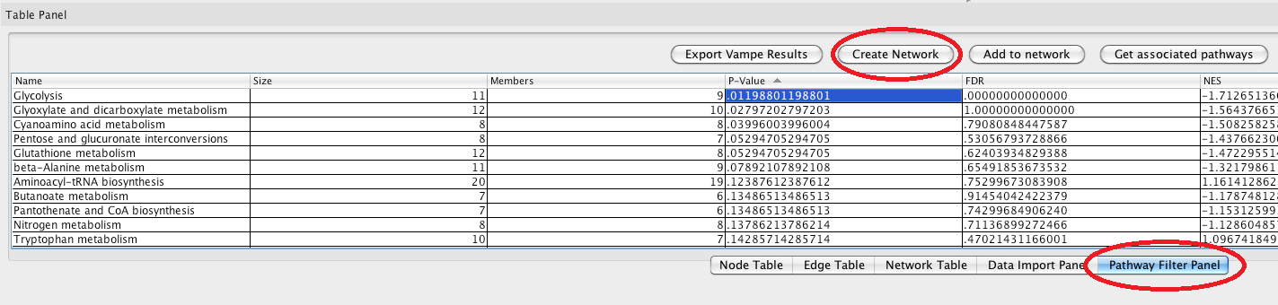

* Selecting one or multiple pathways and pressing the “create network” button will build a network with all selected pathways.
* Selecting one or multiple pathways and pressing the “add to network” button will add those pathways to the currently active network.
* Highlighting a node and selecting the “get associated pathways” button will display all metabolic pathways containing that particular metabolite.
* Back in the **Data Import Panel**, highlighting an element in a data column and selecting the “apply data to networks” button will look up nodes in your network based on their KEGG or HMDB id’s and add that data as an attribute. Only one datum can be applied to each node. This data can then be interpreted through the VizMapper, which has its own tab on the left side panel.

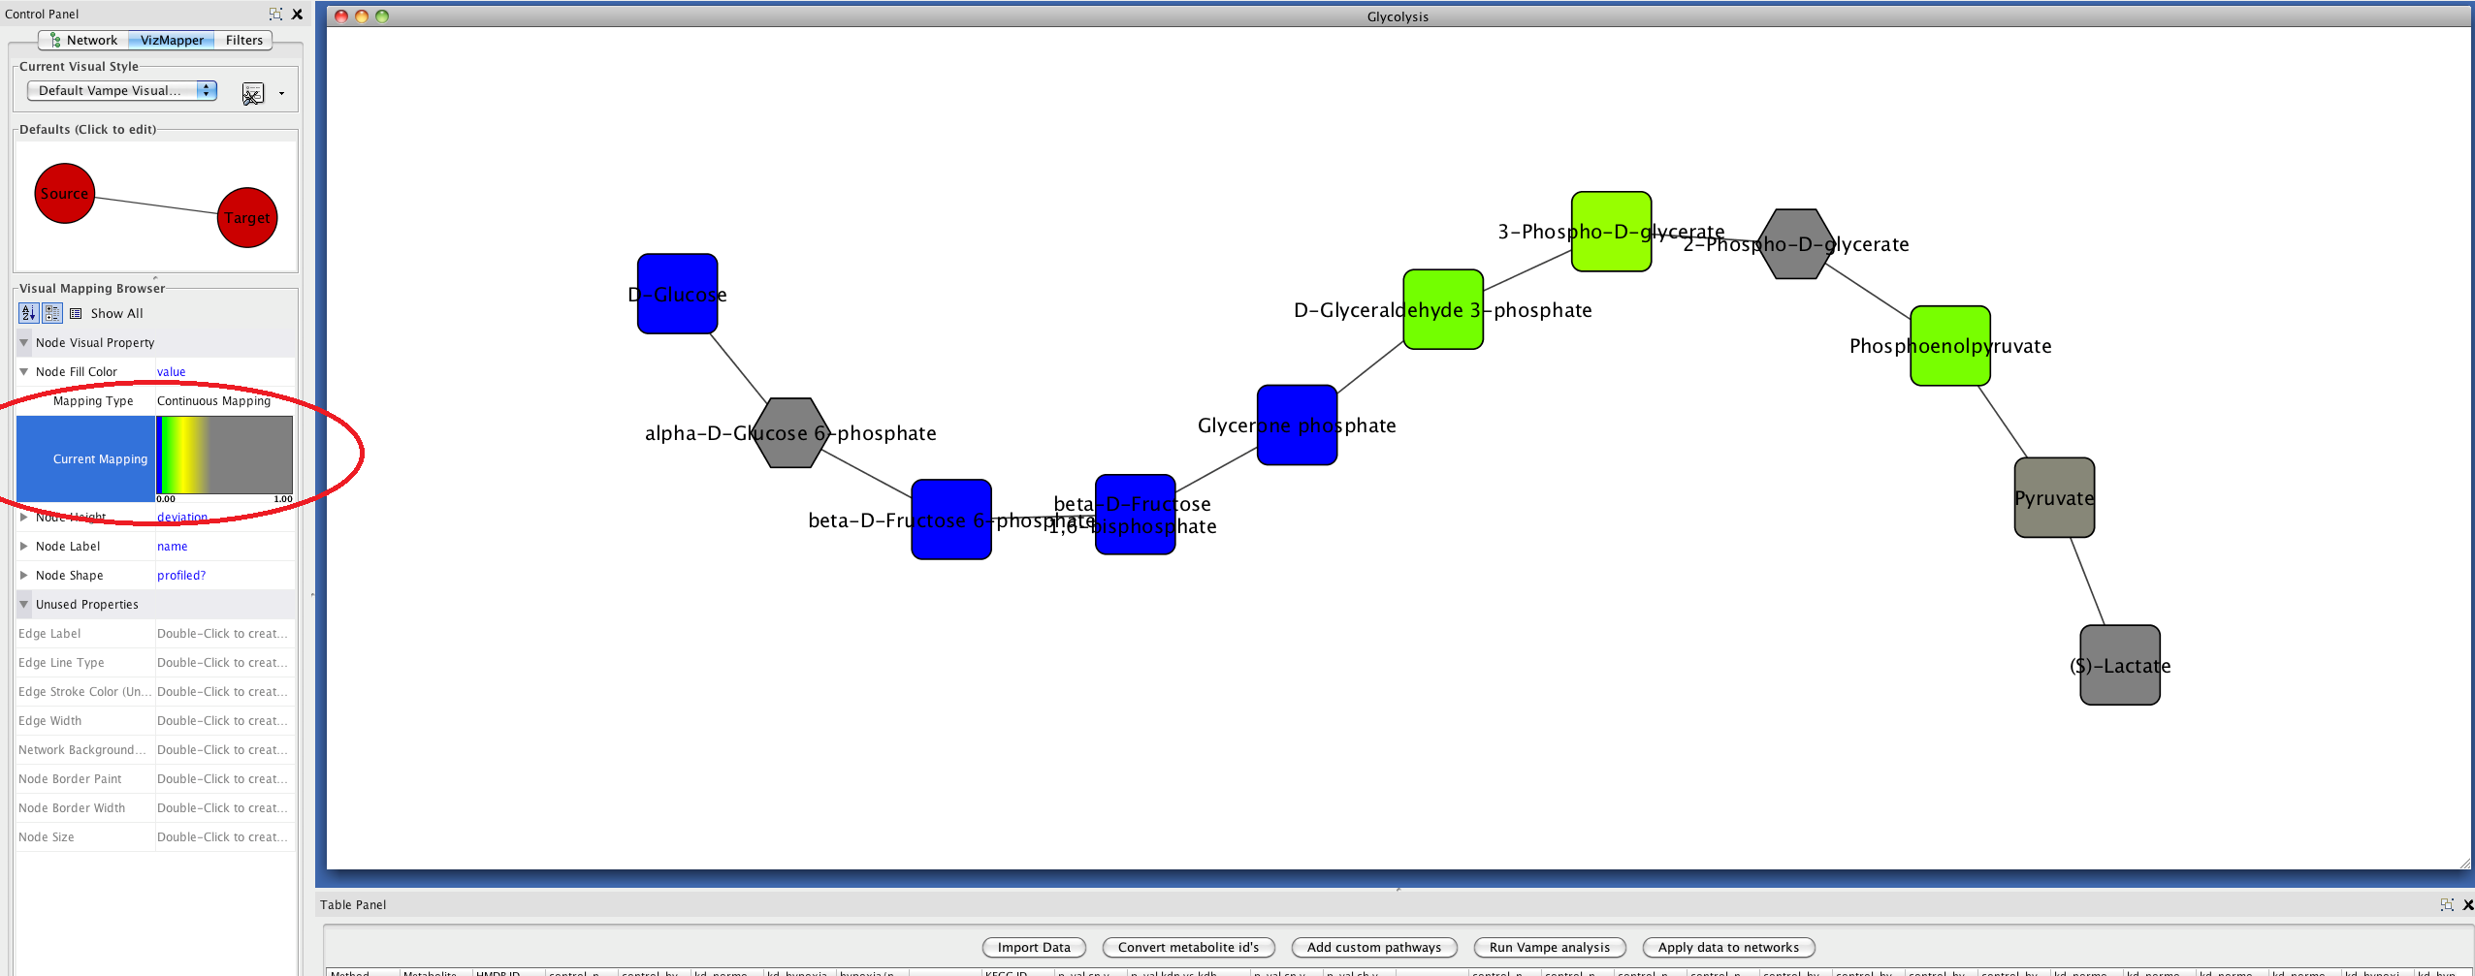

* In the **Network Panel** on the left, open networks can be navigated through.
* In the **VizMapper Panel** on the left, specific visual properties can be applied to your network based on node and edge properties. These vary from adjusting the size of certain nodes to applying color gradients.
* In the **Filters Panel** on the left, filters can be created which select certain nodes or edges based on their attributes.
* In the **File Menu,** your network can be saved and exported as an xml-like file type or as one of many image types.
* In the **Layout Menu**, specialized layouts can be applied to your network to visualize them in different ways; however, the default preferred layout is likely to be the most straightforward layout.

For any help needed with handling the Cytoscape interface, such as applying specialized layouts, manipulating the VizMapper, etc, please visit: http://opentutorials.cgl.ucsf.edu/index.php/Portal:Cytoscape3

Laying out a pathway (.pwf) file

Customizable metabolic pathways may be added quickly and simply in a text editor or excel. As an example, we have laid out a sample .pwf below. To create a .pwf, simply create a text file with three columns, separated by tabs. The first column should have the name of your pathway, followed by the names of the metabolites in your pathway. The second column should contain a list of HMDB ID’s. Finally, the last column should contain a list of all nodes connected to that particular node, separated by semicolons. Connections only need to be made in one direction, so connecting two nodes to each other is unnecessary (though acceptable). After loading a .pwf, it will appear in the **Pathway Filter Panel** after an analysis is run. Your pathway will NOT be displayed, however, if fewer than six metabolites in your data set are mapped to your pathway. This is to ensure pathways are large enough to yield accurate results.

|  |  |  |
| --- | --- | --- |
| My Favorite Pathway | HMDB ID | Connected Nodes |
| Metabolite 1 | HMDB00001 | HMDB00002;HMDB00003;HMDB00004; |
| Metabolite 2 | HMDB00002 | HMDB00006 |
| Metabolite 3 | HMDB00003 | HMDB00002;HMDB00004 |
| Metabolite 4 | HMDB00004 | HMDB00005 |
| Metabolite 5 | HMDB00005 | HMDB00006; |
| Metabolite 6 | HMDB00006 |  |